# *Web Programming I (420-C10-HR)*

# *Lab 11 – Positioning and Responsive Web Design*

Date assigned: Monday, November 9, 2015

Date due: **Friday, November 13, 2015**

**Learning Objectives**

Upon successful completion of this lab exercise, the student will be able to:

* Work with Responsive Web Design
* Work with positioning in CSS

To do:

**Lab Set-Up**

1. Copy the C10_L11 zip file from Moodle and unzip it to your H:\420-C10\Labs folder. Rename the folder to **YourUserName_C10_L11**.

**Part A: Textbook Exercises**

1. Complete questions 1 through 7 on page 279 of your textbook. Put the answers in this document. Put the answers in a file called part_a.css in the part_a subfolder. Note: you do not need to add an html page, but might want to make sure your CSS works.

**Part B: Pacific Trails**

1. It’s been a while, but we are going to go back to the Fish Creek Animal Hospital website case study. In Dreamweaver, create a site (manage sites) called “YourUserNameL11B” in your Labs folder of C10 folder on your H drive. Use the directory H:\C10\Labs\YourUserName_C10_L11\part_b. Complete the Fish Creek Animal Hospital case study on pages 284 to 287 of your text. Remember to validate your page and your CSS. Make sure you use the full tags with ending tags and proper attributes.
2. I have given you the start files in the part_b folder that you copied at the beginning of the lab.
3. For Task 3, skip step 1 (and Task 4 and 5 when they talk about the HTML5 shim). Instead add the meta tag from class that makes IE use the most up-to-date version (see notes from class).

**Part C – Responsive Web Design – Multiple CSS Files**

1. In Dreamweaver, create a site (manage sites) called “YourUserNameL11C” in your Labs folder of C10 folder on your H drive. Use the directory H:\C10\Labs\YourUserName_C10_L11\part_c to store your files.
2. Open the file rwd.html. You are going to add three CSS files to this file to display it for different devices.
3. Start by creating a CSS file called desktop.css in the styles subfolder.
4. Add the following properties to the CSS file:
   1. The body has a background colour of #CCC;
   2. The wrapper div:
      1. Has 90% width
      2. Is centred from the left and right (ONLY)
      3. Has a background colour of 03f
      4. Automatically overflows the content
   3. The banner div:
      1. Has a background colour of 009
      2. Has a width of 100%
      3. Has a text colour of FFF
   4. The navigation div:
      1. Has a padding top and bottom of 0 and a padding left and right of 2 px
      2. Floats to the left of the screen
      3. Has a width of 10 width of the letter M
      4. Uses the font family Verdana, Geneva or the default sans serif font (in that order)
   5. The h1 element:
      1. Uses the font family Tahoma, Geneva or the default sans serif font (in that order)
      2. Has a font size of 3em
      3. Has the text transformed to upper case
      4. Has the text aligned to the centre of the screen
   6. The list items in the unordered list that is part of the nav div:
      1. Has the text aligned to the centre of the div
      2. Has a thin, solid, white border
      3. Has no list bullets
      4. Has the colour ff3
      5. Has a padding of 2px on all sides
   7. The content div:
      1. Has a background colour of f63
      2. Is padded 5 px on the right
      3. Floats to the left
      4. Has a width of 80%
      5. Uses the font family Verdana, Geneva or the default sans serif font (in that order)
5. Attach the style sheet to the file rwd.html when the media type is screen. The resulting file, viewed in a browser, looks like this:

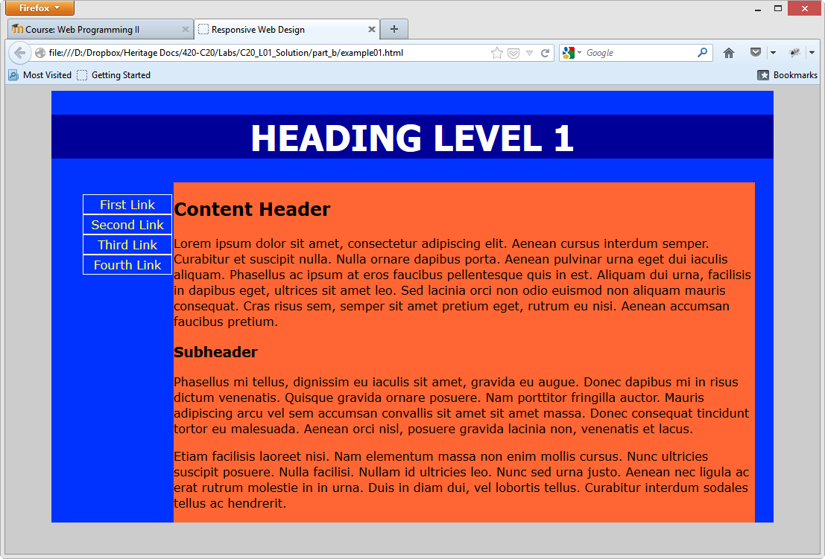

1. Save a copy of the desktop CSS file as tablet.css. Update the tablet.css file as follows:
   1. The wrapper div has only one property which sets the width to auto
   2. Change the banner div to have a background colour of 63c and a colour of 9cf
   3. Change the h1 element to have a font size of 2 em and not transform the text
   4. Change the nav div to have a width of 100%
   5. Change the list items in the unordered list in the nav div to display in one line with the text aligned to the left and a padding of 4px on all sides.
   6. Change the content div so that the background is 006 and the font colour is ff9. Change the width to 100%. Remove the float property from the content nav.
2. Go back to the rwd.html file.
   1. Add a meta tag with the name viewport and the content of “width=device-width, initial-scale=1.0, maximum-scale=2.0, user-scalable=yes”
   2. Add a link tag with the file when the media is: "handheld, only screen and (max-width: 800px), only screen and (max-device-width: 800px)" to use the stylesheet tablet.css
3. View the file in a browser and make the browser narrower (if you like you can enter responsive design mode in FireFox by pressing Ctrl-Shift-M). When you get to 800 pixels wide the display should change to the following:

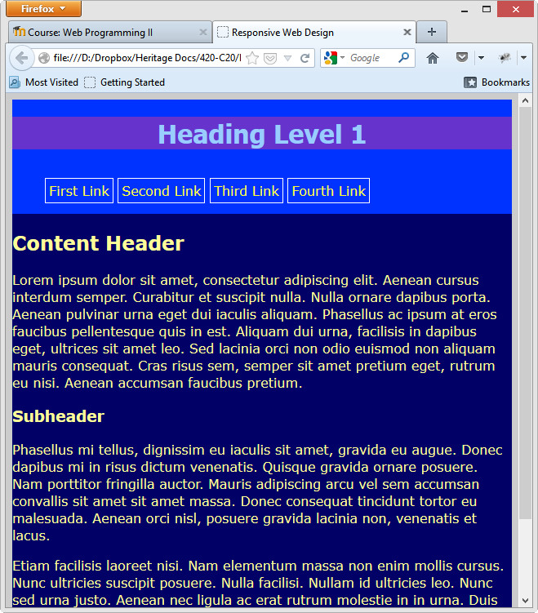

**Part D – Responsive Web Design – Media Queries**

1. In Dreamweaver, create a site (manage sites) called “YourUserNameL11D” in your Labs folder of C10 folder on your H drive. Use the directory H:\C10\Labs\YourUserName_C10_L11\part_d to store your files.
2. View the file part_d.html in a browser. It looks like this:

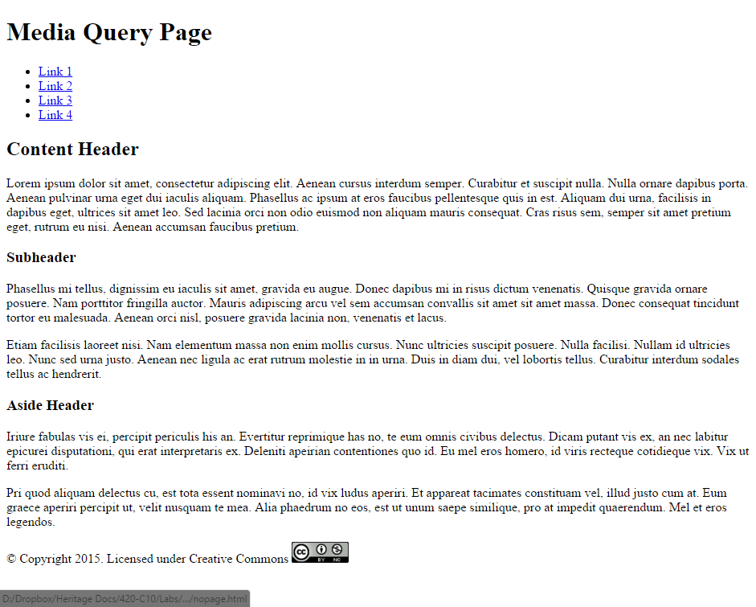

1. The file part_d.css is already linked to the html file. You will need to add CSS as follows:
2. We will start with mobile design. Add CSS as follows:
   1. For the body use the Verdana, Geneva, sans-serif font family, set the font size to 1em, the line height to 1.5em, the font weight to normal and the background colour to #c1b58
   2. The ID wrapper has a width of 100% and sets the margin right and left to auto to centre the wrapper on the screen.
   3. The header element has a width of 100%, the text aligned to the centre, the background colour #00004f, The font colour #e0e0e0 and sets overflow to auto and pads top and bottom to 2px and left and right to 0px.
   4. The nav element has a width of 100%, a background colour of #006633 and aligns the text to the centre of the screen. It also has a padding top and bottom of 2px and left and right of 0px.
   5. For and list items in an unordered list inside the nav element (nav ul li) add CSS to display inline, have no list style, padding left and right of 10px and a border which is thick, solid and in the colour #00004f with a border radius of 10px.
   6. For anchor tags inside these list items (nav ul li a) make the font colour #00004f and have no text decoration.
   7. Add a class called .notMobile which sets the display to none.
   8. Add CSS for the section element to set the background colour to #ffb76f and padding on top and bottom set to 2 px.
   9. Add CSS for the aside element to set the background colour to #ff6633, the font colour to #f4f4f4 and pad the top and bottom to 2 px.
   10. Add CSS for the footer element to have the font size at 0.7em, a background colour of #cacaff, the text aligned to the centre, padding top and bottom to 2px and a top border which is solid, thin in width and has the colour #003333.
   11. Lastly, add CSS to align the image in the footer (footer img) to be vertically aligned to the middle.
3. Display the page in a browser now and it should look like this:

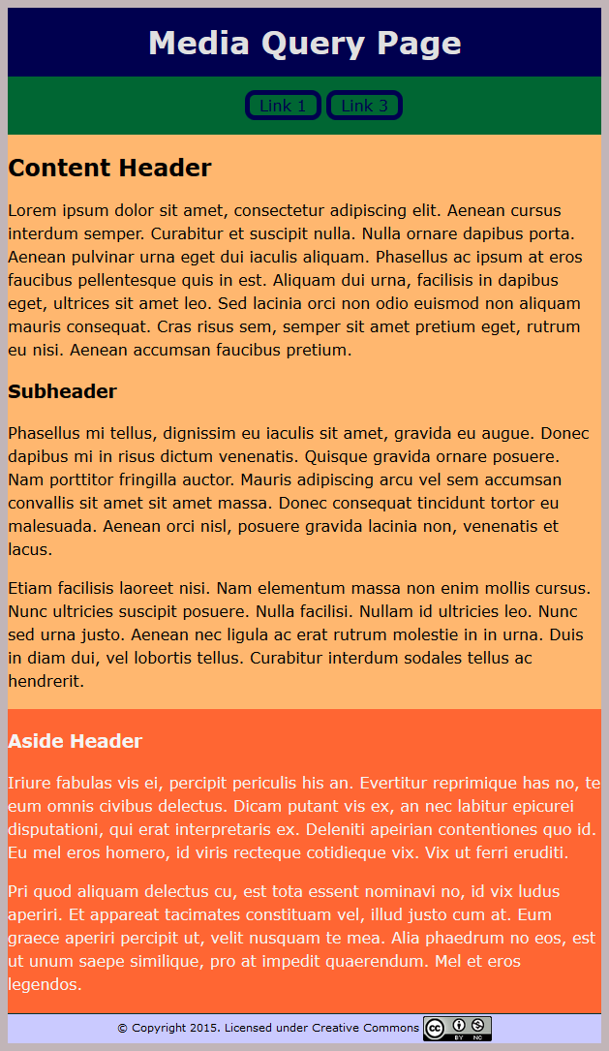

1. Add a media query to the CSS for all devices where the minimum width is 650px. Inside this query set the following CSS:
   1. A body tag whose only property is to set the font-size to 0.9em.
   2. A notMobile class whose only property is to display inline. This will have to be important to make sure it is used (!important).
2. Display the page in a browser now and, as you move from narrower than 650px wide to wider, the page should look like this:

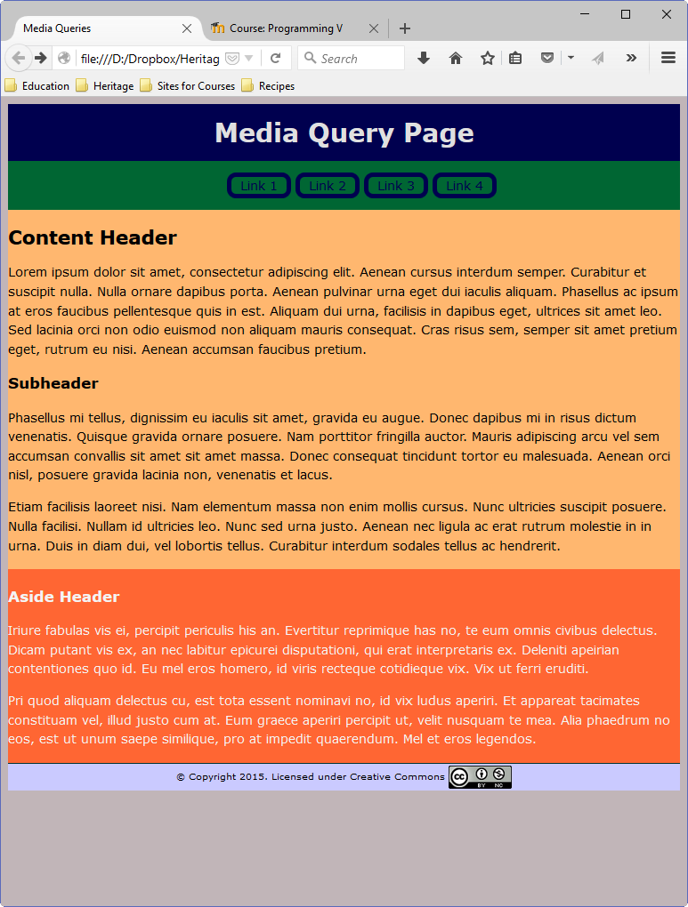

1. Add another media query to the CSS for all devices where the minimum width is 800px. Inside this query set the following CSS:
   1. Set the wrapper ID to have a maximum width of 850px and a width of 90%.
   2. Set list items in the nav element (nav ul li) to have no border
   3. Set the hover pseudo class of anchor tags inside the list items (nav ul li a:hover) to have a italic font, a font colour of #9595ff and a font size of larger (yes, use the word larger).
   4. Set the section element to have a width of 67.5% and float left.
   5. Set the aside element to have a width of 30%, float right and have a font size of 0.7 em.
   6. Set the footer element to have the property clear: both (to clear the floats above).
2. Display the page in a browser now and, as you move from narrower than 800px wide to wider, the page should look like this:

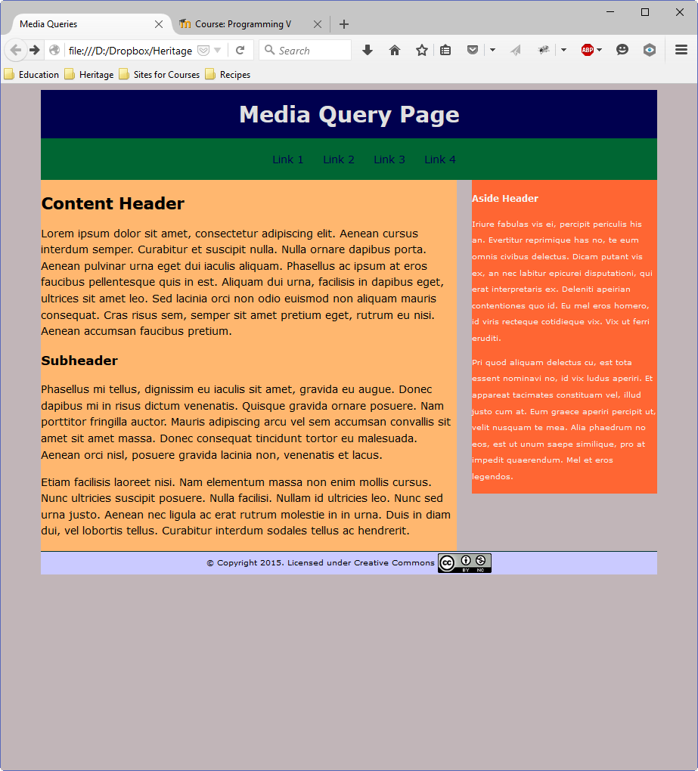

1. Note, as the page gets wider and wider, the size of the wrapper div stops expanding once it reaches 850px. A wider page looks like (note the link is being hovered over at this point):

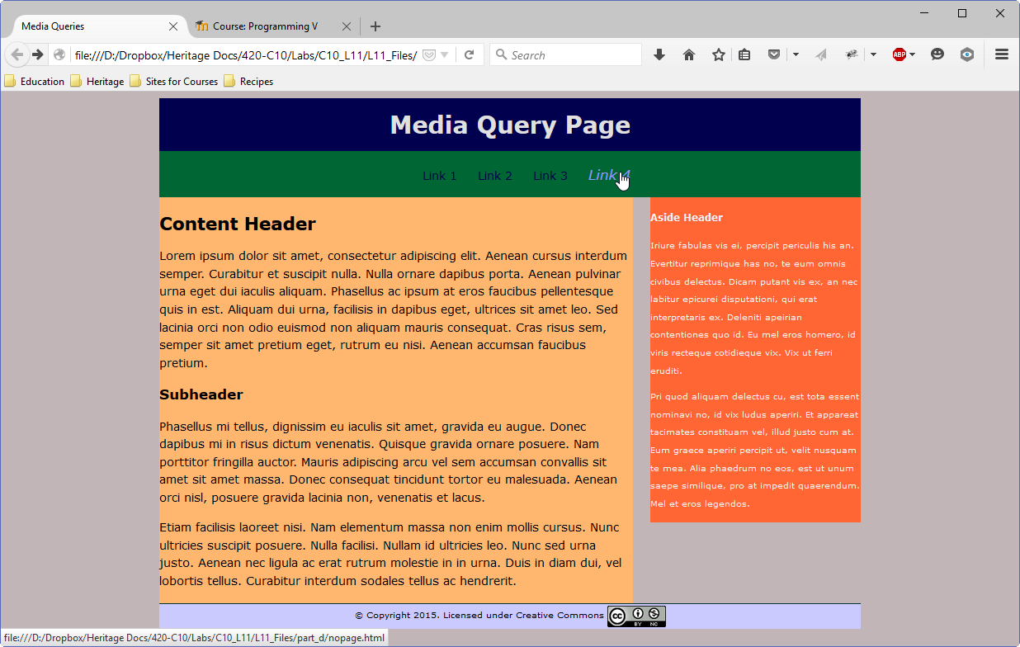

**To submit**

When you have completed the lab exercise, create a zip file of all the files in your L11 folder. Call the zip file YourUserName_C10_L11.zip and copy it to the Moodle page for the class. The zip file must contain:

* All the files required for the websites (html, CSS and image files).